WEEK-3

PROGRAM-1

1. Create a java program with the following instructions.Use constructor

* Create a class with name Car
* Create 4 attributes named car_color,car_brand,fuel_type,millage
* Create three methods named start(),stop(),service()
* Create a three objects named car1,car2,car3
* Create a constructor which should print welcome to car garage

Program:

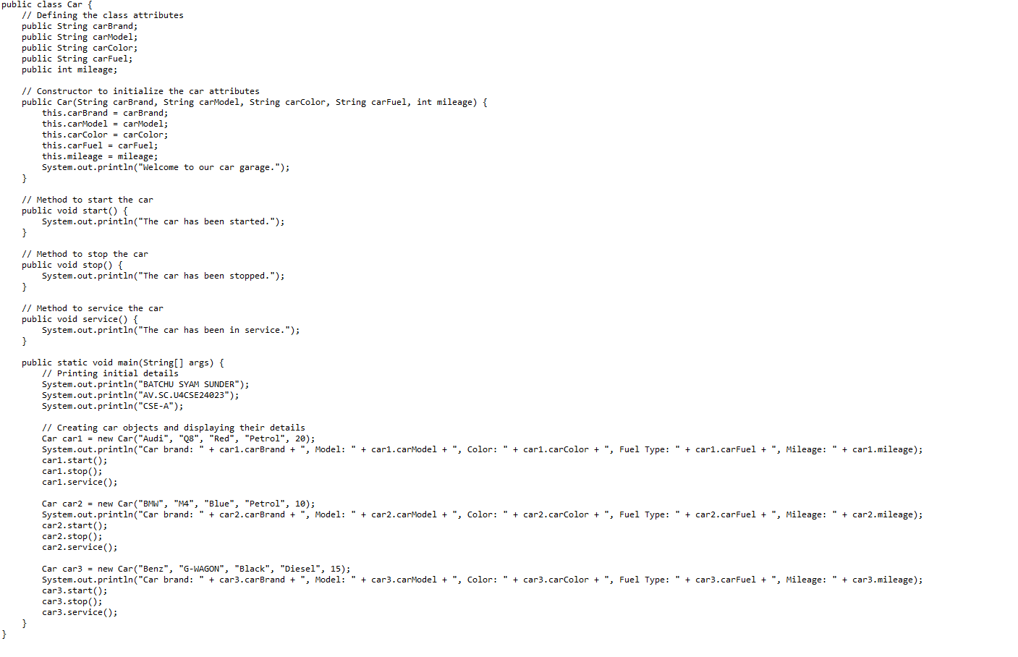

OUTPUT: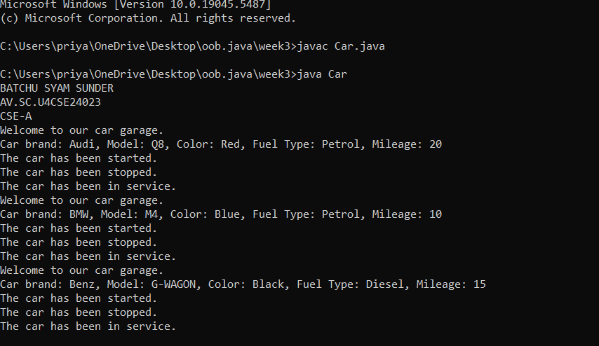

**Error:**

|  |  |  |
| --- | --- | --- |
| **Error Type** | **Incorrect Code** | **Corrected Code** |
| **Class Naming Issue** | class main{ | class Main{ |
| **Incorrect Object Description** | "Our first car is "+car2.car_brand; | "Our second car is "+car2.car_brand; |
|  |  |  |
|  |  |  |

**CLASS DIAGRAM**:

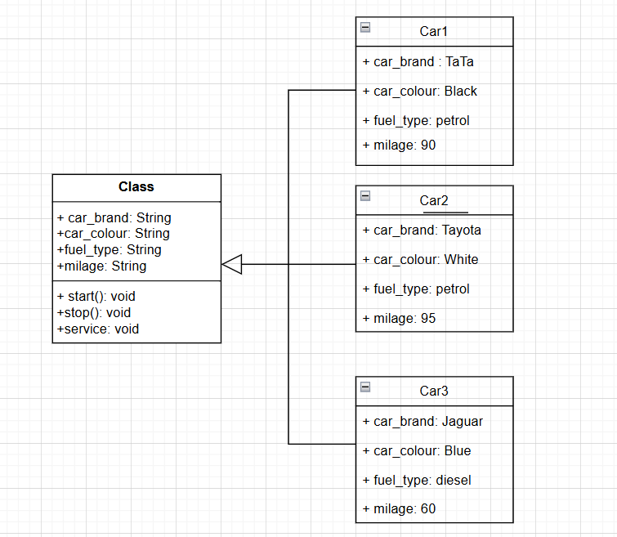

PROGRAM-2

2.write a java program to create a class named bank account with two methods deposit and withdrawal

* In deposite method an account is deposited it has to be updated with the current amount.

* withdrawal method whenever an amount is withdrawn if has to be less than the correct amounts else print insufficient funds.

PROGRAM:

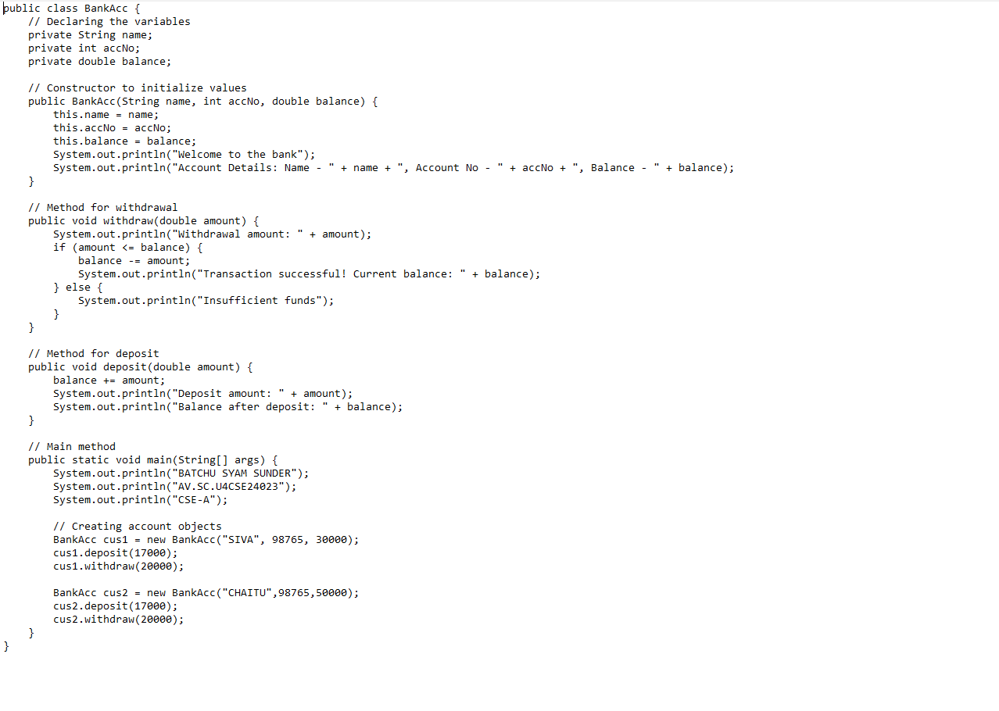

OUTPUT:

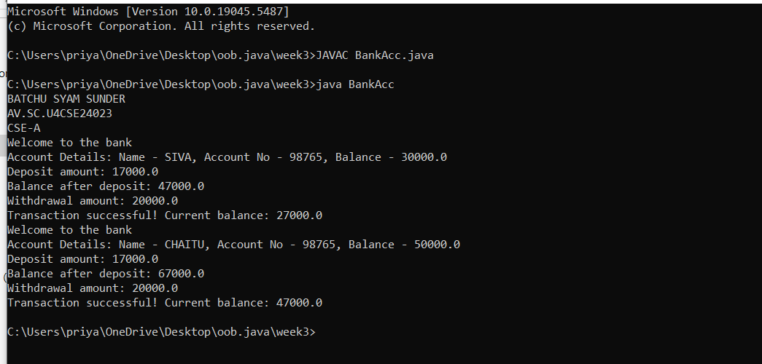

ERRORS:

|  |  |  |
| --- | --- | --- |
| **Error Type** | **Incorrect Code** | **Corrected code** |
| **Class Name Capitalization** | class Bankaccount | class BankAccount (Java follows PascalCase for class names) |
| **Object Naming Issue** | BankAccount person-1 (hyphen is not allowed) | BankAccount person1 |
| **Missing Semicolon** | System.out.println ("Balance is "+ person-1.deposit (50,000)) | System.out.println ("Balance is "+ person1.deposit (50000)); (semicolon added) |

CLASS DIAGRAM:

